Week 2 – X-ray diffraction practical – 10 October 2025

Useful equations:

0.5mv² = e.V
Speed v of an electron, with m = mass electron = 9 × 10⁻³¹ kg, e = electronic charge = 1.6 × 10⁻¹⁹ C, and V = potential difference.

E = hυ
Energy = Planck’s constant × Frequency, with h = 6.626 × 10⁻³⁴ J.s

λυ = c
Wavelength × Frequency = speed of light, with c = 3 × 10⁸ m s⁻¹, and 1 eV = 1.6022 × 10^{–19} J

n.λ = t.sin(α)
Maximum intensity for monochromatic light diffracted of a grating, with λ = wavelength of incident beam, t = grating spacing, and α = maximum intensity diffraction angle.

nλ = 2d.sin(θ) – Braggs’ law
Constructive interference for X-rays diffracted from crystal lattice planes, with λ = wavelength of incident X-ray beam, d = distance between planes, and θ = incident angle.

- To produce characteristic X-rays from a target, the kinetic energy of electrons must exceed the electron binding energy in a given atom shell.
The K-shell electron binding energies for copper (Cu) and tungsten (W) are 8.979 keV and 69.525 keV, respectively.

a. Your X-ray production tube can be set at accelerating voltages of 5 kV, 20 kV, and 100 kV. What accelerating voltage will you use to produce characteristic Kα X-rays for the Cu target? And for the W target?

We want kinetic energy of incoming electron > binding energy K shell electron
For a single electron, 1 kV = 1 keV.
So will use 20 kV for Cu, and 100 kV for W. Note that you can also use 100 kV for both.

b. At what speed will electrons travel for these two accelerating voltages?

0.5mv² = e.V → v = √(e.V/0.5m) with V in volts and m in kg

@ 20 kV = 20,000 V → v = 8.43 × 10⁷ m s⁻¹, which is 28% the speed of light.
@ 100 kV = 100,000 V → v = 1.89 × 10⁸ m s⁻¹, which is 63% the speed of light.

- What is the frequency (per second) and energy (in both J and eV) of the Cu Kα (1.54 Å), Mo Kα (0.71 Å), Ag Kα (0.56 Å), and W Kα (0.21 Å) X-ray beams?

λυ = c → υ = c/λ and E = hυ
X-ray | Z | λ (Å) | υ (s⁻¹) | E (J) | E (eV)
Mo Kα | 42 | 0.71 | 4.23×10¹⁸ | 2.80×10⁻¹⁵ | 17474
Cu Kα | 29 | 1.54 | 1.95×10¹⁸ | 1.29×10⁻¹⁵ | 8056
Ag Kα | 47 | 0.56 | 5.36×10¹⁸ | 3.55×10⁻¹⁵ | 22155
W Kα | 74 | 0.21 | 1.43×10¹⁹ | 9.47×10⁻¹⁵ | 59079

- What should the spacing of scatterers in a ripple tank be so that waves with wavelength of 4 cm will be scattered constructively at 45°?

Want to use n.λ = t.sin(α)
with λ = wavelength of incident beam/waves, t = grating/scatterer spacing, and α = maximum intensity diffraction angle.

t = n.λ / sin(α), with n = 1, so t = 0.04 m / sin(45°) = 0.0566 m = 5.66 cm

- A previous PhD student, Zen, worked on the Stac Fada unit in Northwest Scotland for their PhD research (https://en.wikipedia.org/wiki/Stac_Fada_Member), which is ~10 m thick deposit assumed to have formed from an impact event ~1.0 billion years ago.

To get an overview of the mineralogy of some of the samples, Zen powdered small chips and performed some X-ray diffraction analyses. In the equipment used, the X-ray source is copper. The X-ray diffractogram obtained is shown below, with intensity vs. 2θ angle provided in the accompanying Excel spreadsheet.

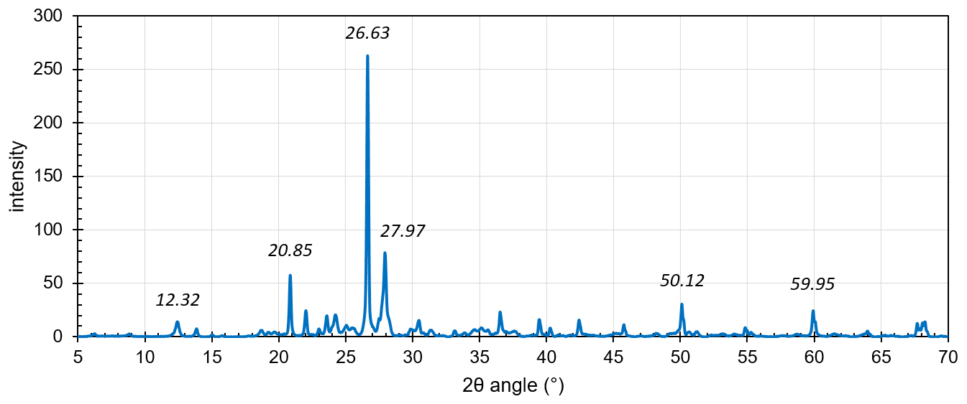

a) Some of the 2θ angles for some prominent peaks are labelled on the diffractogram. Calculate the corresponding d-spacings.

2θ angle (°) | θ angle (°) | in rad | sin(θ) | d spacing (Å)
12.32 | 6.2 | 0.1075 | 0.1073 | 7.18
20.85 | 10.4 | 0.1820 | 0.1809 | 4.26
26.63 | 13.3 | 0.2324 | 0.2303 | 3.34
27.97 | 14.0 | 0.2441 | 0.2417 | 3.19
50.12 | 25.1 | 0.4374 | 0.4236 | 1.82
59.95 | 30.0 | 0.5232 | 0.4996 | 1.54

b) To decipher the bulk mineralogy of this sample, we are going to need X-ray diffraction data for a range of common mineral phases.

- Go to https://rruff.info/ and download processed X-ray data for forsterite, albite, enstatite, quartz, clinochlore, and microcline (select the first mineral for each list).
- Import the intensity vs. 2θ angle for each mineral in an Excel spreadsheet.
- Using these data, identify which phases are present in Zen’s sample.
- Consider how the intensity of the peaks might relate to the relative abundance of each phase in the power sample. What phase is most common?

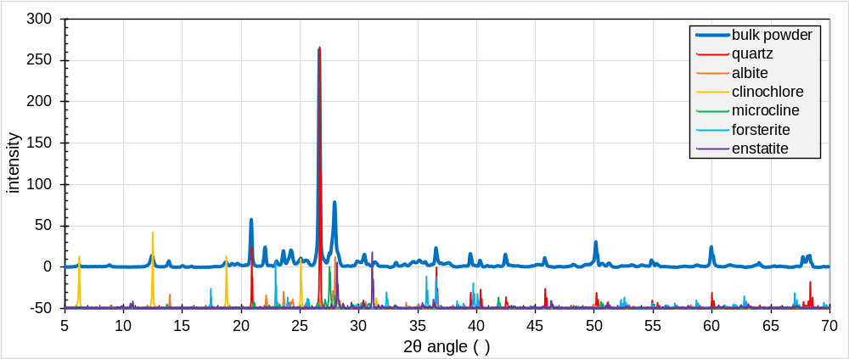
Mostly quartz + albite + clinochlore + microcline

See spreadsheet called “Week2_XRD_Practical_Plots.xlsx” for data and plots.

Bonus: have a look at some other minerals (e.g., coesite, muscovite, biotite, chlorite) and 1) see if they exist in the sample, and 2) estimate their abundance

